How to compile build on Jenkins
open to the aws console page, then enter the login details select the Jenkins instances trun the instance,
open the putty enter the ip address and key pair,
start the Jenkins service check the Jenkins status,
go to instances copy to the Jenkins ip address then go to the search bar enter the ip address and Jenkin port number, example [192.168.1.47:8080]

now Jenkins display the like this page click on the new item here create to the project,
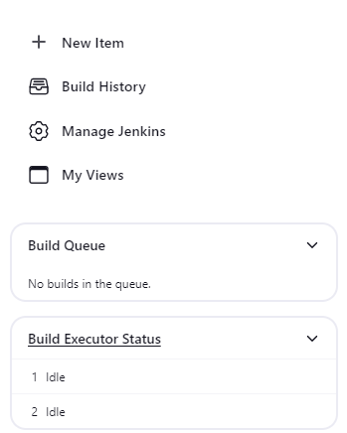

Here enter the your new item name and select to the one option below then click on ok icon

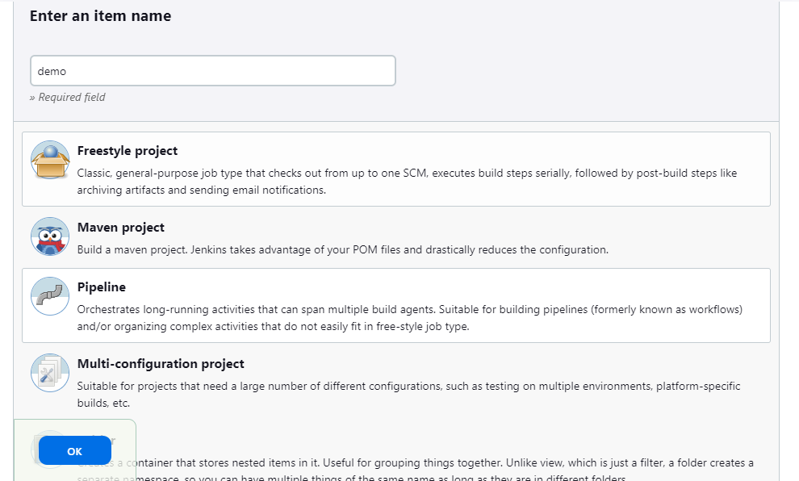

Enter the your project smiler name

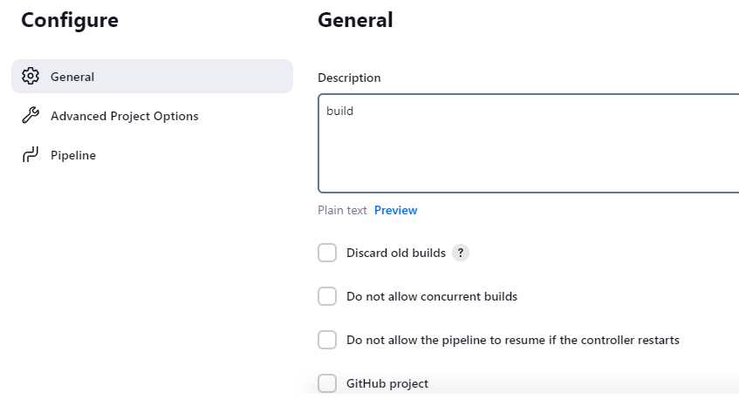

It is main, here write the script what ever u want like I wann code fetch remote repository to Jenkins

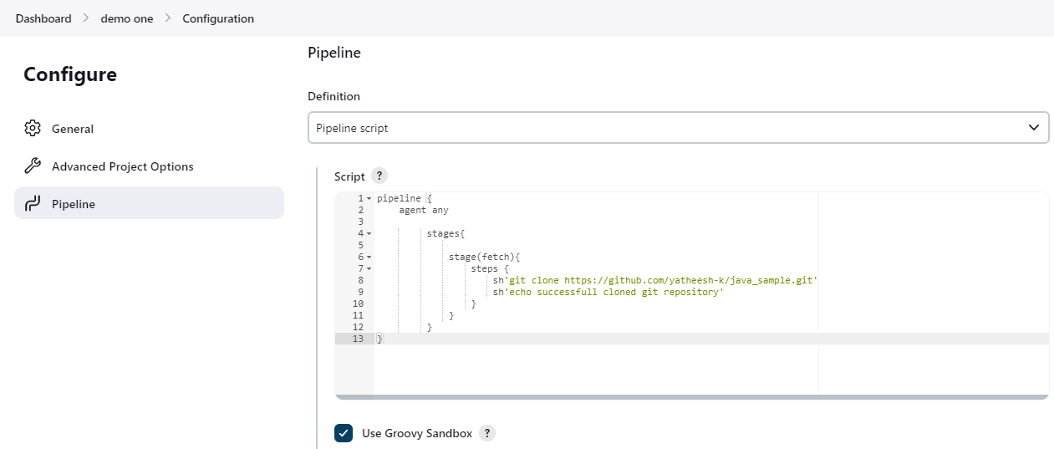

Once completed write your code then ckick on apply icon and save icon,

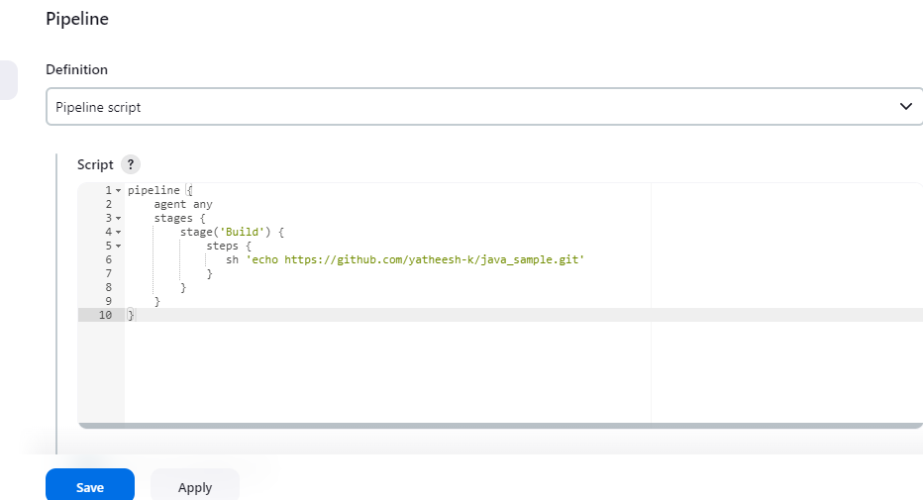

Then go to the dashboard, here display the your project name click on that project name
Once you click on the project name it display the like below page,
Click on the build now potion,
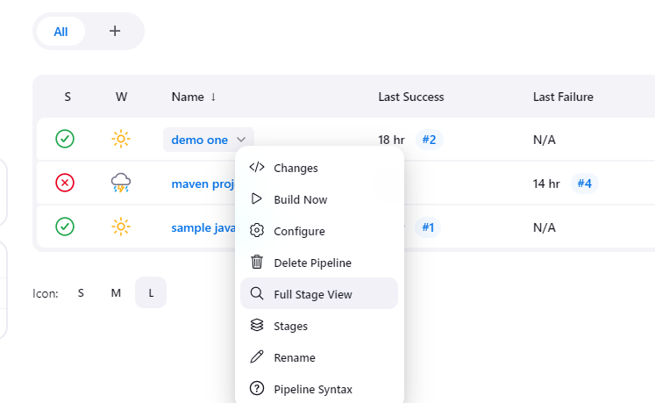

Come to the bashboard and click on your project name then click on console icon here display the your code errors,. Here not display the code errors your code successful fetch from git repository,

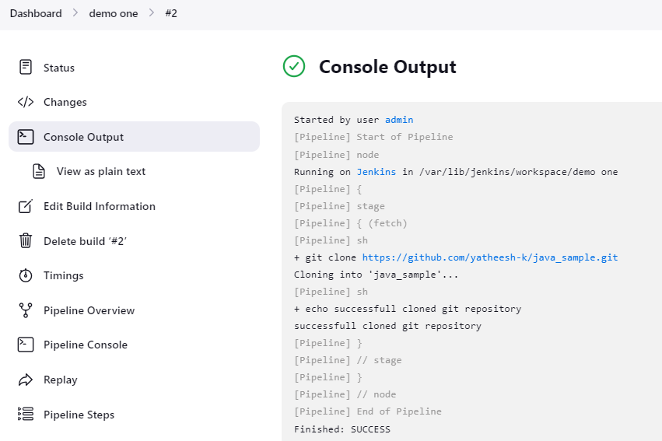

Stage show the like this page like lite green colour it’s means your code successful fetched

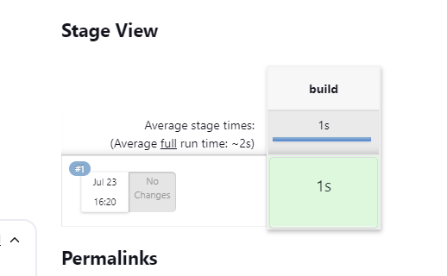

Here success the your code fetching

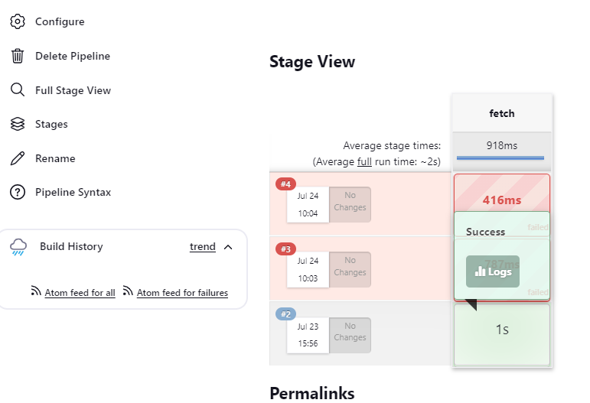
Here failed the fetching your code, once code failed display the like this lite red colour, lite red colour display means your code is failed,

